RE EXAM- Continuous Assessment Exam (Even Sem 2021-22)
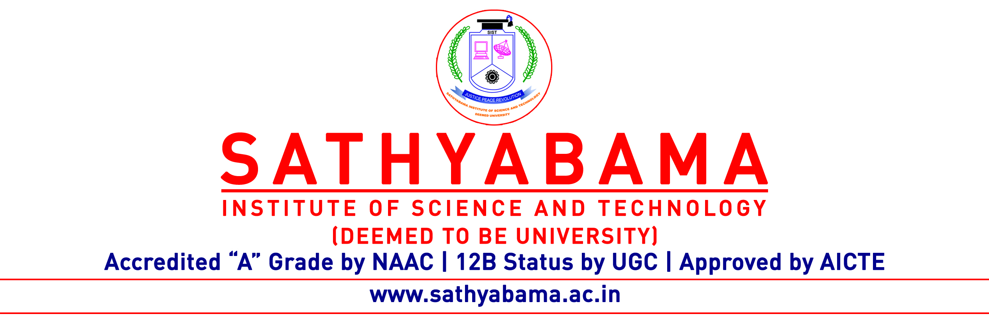
Program : CSE/IT Max. Marks : 30
Course : Machine Learning Time : 1 Hour
Course code : SCSA1601 Sem : VI
Batch : 2019-2023 Date : 04-05-2022
Part-A Answer ALL the questions (5×2=10)

Q.No | Questions | CO (L)
 | List out few applications of Machine learning.
 | How do you compute Support count and Confidence in Apriori algorithm?
 | Demonstrate Regression.
 | What is Agglomerative and Divisive Clustering?
 | How will you calculate the error in a Neural network.

Part-B Answer ALL the questions (2×10=20)

Q.No | Questions | CO (L)
 | Explain about Supervised learning in detail.
 | (OR)
Estimate frequent itemsets using Apriori algorithm. Given below is a database that contains five transactions with minimum support count = 3 and minimum confidence = 80%. Find their associations.
TID | Items
T100 | { M, O, N, K, E, Y}
T200 | { D, O, N, K, E, Y}
T300 | { M, A, K, E}
T400 | { M, U, C, K, Y}
T500 | { C, O, O, K, I, E}

Assume the points X1=(0,2), X2=(0,0), X3=(1.5, 0), X4=(5,0) and X5=(5,2) with C1={X1,X2,X4} and C2={X3,X5} as their initial clusters. Apply K-means algorithm to find the new clusters.
(OR)
Construct a Single Layer perceptron and explain it with an example.

